Primary Prevention Teaching Plan

Student’s Name
Institutional Affiliations
Date
Introduction
This report will discuss the primary prevention plan of diabetes type 2 disease. The facts concerning diabetes type 2such as the mortality and morbidity rate, are the report's major topic. The report will also include brief pathophysiology of the disease and the 2020 health goal of the disease. Furthermore, the report will assess the risk factors associated with the disease and the risk factors associated with the patient. Lastly, the report will include one picture showing the teaching about the diseases.
Diabetes type 2 disease is the major disease discussed in this report. The disease is majorly concerned with how the human body deals with the level of blood sugar. Diabetes type two is a chronic disease because those who suffer from it can survive for many years. The statistics show that the disease majorly affects the elderly and the adults in society. About 95% of patients diagnosed with diabetes are Adults; the probability shows that one person out of three adults has diabetes. Furthermore, 10% of mothers have diabetes type 2 after giving birth. The disease is very uncommon in children. Statistics show tha12.3% of youth suffer from diabetes. Lastly, the chances of suffering from diabetes type 2 increase with age.
A cardiovascular complication mainly causes the rate of mortality of type 2 diabetes to increase. The statistics show that there is a high rate of the mortality rate of diabetes among people aged 50 to 60 years. Furthermore, the disease rate is also associated with racial differences; for example, there are higher chances of death from blacks than whites.
The disease pathophysiology is characterised with failure to control the production of hepatic glucose and reduction in production of Beta – cell function hence causing to beta – cell failure. Furthermore, either production of enough insulin mainly causes the disease in the body or develops insulin resistance. The insulin resistance of the body occurs where a body part or a cell refuses to respond to insulin despite its presence in the cells (Bellou et al., 2018). The diabetes type two may also be inherited from the family members since the disease is genetically transmitted. In other words, diabetes type two disease is associated with the body's failure to control blood sugar.
The healthy people 2020 goals of diabetes type 2 disease include increasing the blood sugar testing kits for diabetes patients to monitor their blood sugar effectively. The provision of blood sugar testing kits helps the patients effectively monitor the blood sugar level and help control the disease (Chatterjee, Khunti & Davies, 2017). Finally, healthy people2020 goals aim at raising the number of diabetes type two patients who go for dental check-ups.
There are several controllable and uncontrollable risk factors of diabetes type 2 disease; the uncontrollable factors include age and genetic infections. Some patients inherit the diabetes type 2 disease from family members; for example, some families have a history of diabetes type two, and therefore the disease is genetically transmitted. Genetically transmitted diseases are uncontrollable. These factors are beyond human control. On the other hand, the controllable risk factors involve the body weight, the distribution of fat in the abdomen, race, ethnicity, and blood lip levels (Zinman, Lachin & Inzucchi, 2016). The controllable risk factors are manageable by practicing a healthy lifestyle and diet.
The patient's body weight is the main cause of type two diabetes from the above risk assessment. The patient's body weight is above the recommended body weight hence stands a higher chance of getting diabetes type two. The patient should avoid taking food that increases the body weight. Lastly, the patient can start doing physical exercises to reduce body weight.
Below is a picture showing various ways to manage diabetes type 2

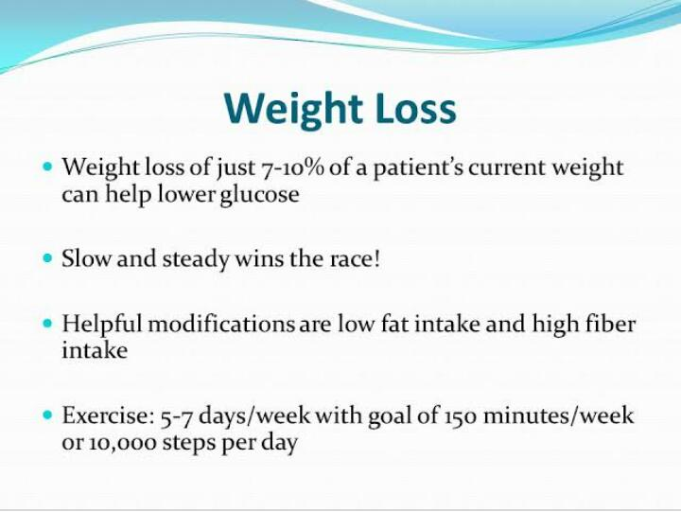
References
Bellou, V., Belbasis, L., Tzoulaki, I., & Evangelou, E. (2018). Risk factors for type 2 diabetes mellitus: an exposure-wide umbrella review of meta-analyses. PloS one, 13(3), e0194127.
Chatterjee, S., Khunti, K., & Davies, M. J. (2017). Type 2 diabetes. The Lancet, 389(10085), 2239-2251.
Zinman, B., Lachin, J. M., & Inzucchi, S. E. (2016). Empagliflozin, cardiovascular outcomes, and mortality in type 2 diabetes. The New England journal of medicine, 374(11), 1094-1094.

